cid:image006.png@01CF952E.32D9C300

**MUFG Union Bank, N.A.**

**Test Evaluation Matrix (TEM) User Guide**

Submitted By

Prashant Garg

**Table of Contents**

1 Agenda 2

2 Pre-requisites 2

3 TEM Worksheets: 3

4 Steps to be used 4

5 Troubleshooting 6

# Agenda

The Agenda of this document is to explain the Test Evaluation Matrix (TEM) report including the pre-requisites we need to maintain in order to get the evaluation based on the release you have selected.

# Pre-requisites

In order to fetch the TEM report there are some pre-requisites we need to follow:

* 1. We need to create the release(s) and Cycle(s) as per below structure. There is no restriction to have the release name but for cycles the name must start from ‘SIT’ or ‘UAT’ as shown below:

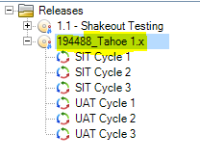

* 1. In test plan module, we are required to follow the same pattern. We need to name the test plan folder same as release name with parent as ‘Subject’ folder. Below is the screen shot for reference

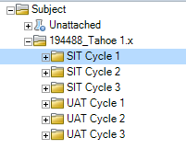

* 1. In test lab module below will be the structure. Here again the release name will be the test lab folder with parent as ‘Root’ folder.

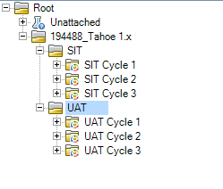

* 1. The test lab folder must be assigned to the respective cycle. Below is the screen shot for reference:

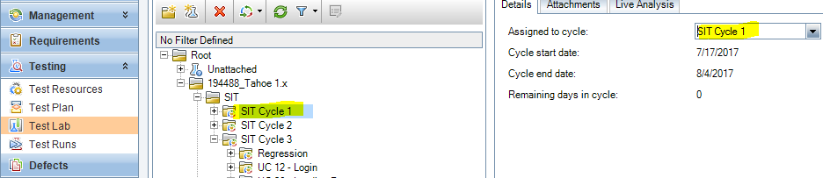

* 1. Planned execution date field in the test instance form of test lab module must be filled as the TEM calculations will be based on this field. If the field is empty then the TEM will not consider that test for evaluation.

# TEM Worksheets:

|  |  |  |
| --- | --- | --- |
| **SIT Sheets** | **UAT Sheets** | **Description** |
| **SIT - Test Execution Tracker** | **UAT - Test Execution Tracker** | Includes information on planned and executed test cases |
| **SIT- Defect Data** | **UAT- Defect Data** | Displays the overall data, including execution status, execution progress, and issues, organized by testing week. |
| **SIT - Project Team Assessment** | **UAT - Project Team Assessment** | Charts testing progress and remaining defects |
| **SIT- QA, HO, Assessment** | **UAT- QA, HO, Assessment** | Charts the number of issues identified, the stability curve, the percentage of issues by cause, and the number of issues that should have been detected in previous phases |
| **Issue Tracker** | **Issue Tracker** | These 2 sheets are used to auto populate information on issues in the Defect Data tabs. |

# Steps to be used

* Open the TEM report and click on ‘Clear Records’ button of ‘Intro’ worksheet

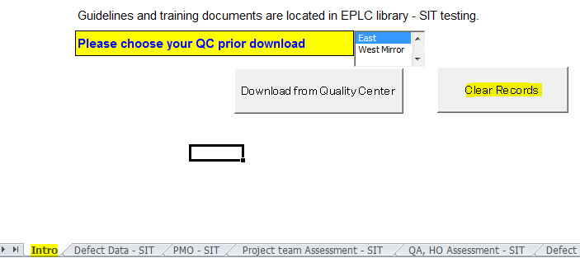

* Now click on ‘Download from Quality Center’ button of ‘Intro’ worksheet

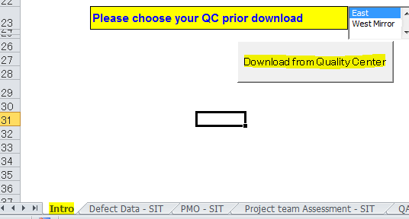

* Below is the userform which will open

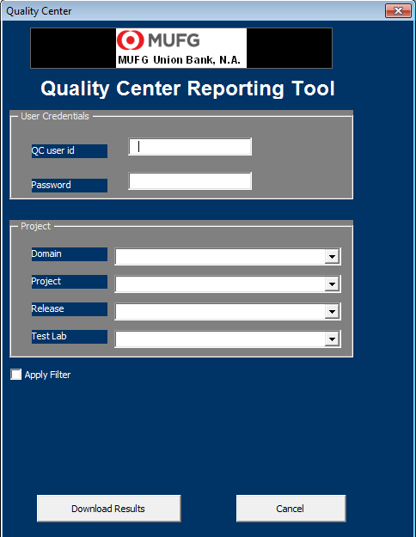

* Provide all the asked details as per below screen shot:

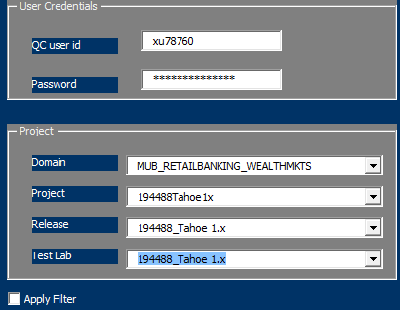

* Now click on ‘Download Results’ button

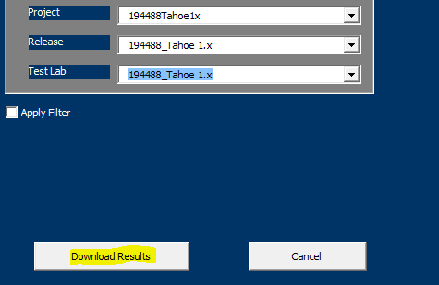

# Troubleshooting

For any troubleshooting or assistance regarding TEM report you need to contact us at Grp_Quality_Center_Support [QualityCenterSupport@us.mufg.jp](mailto:QualityCenterSupport@us.mufg.jp)